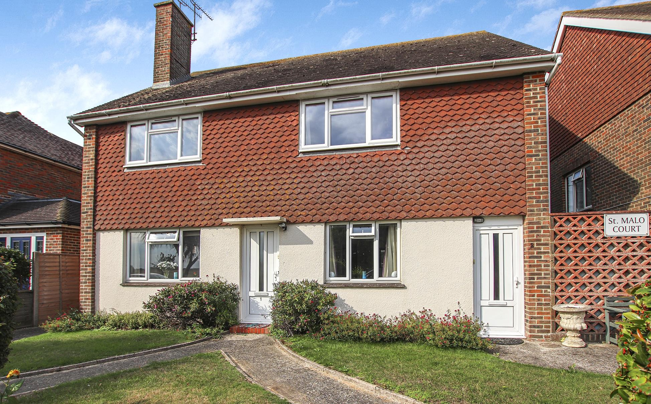

2 St. Malo Court | Ferring | Worthing | BN12 5HE Offers In Excess Of **£325,000**

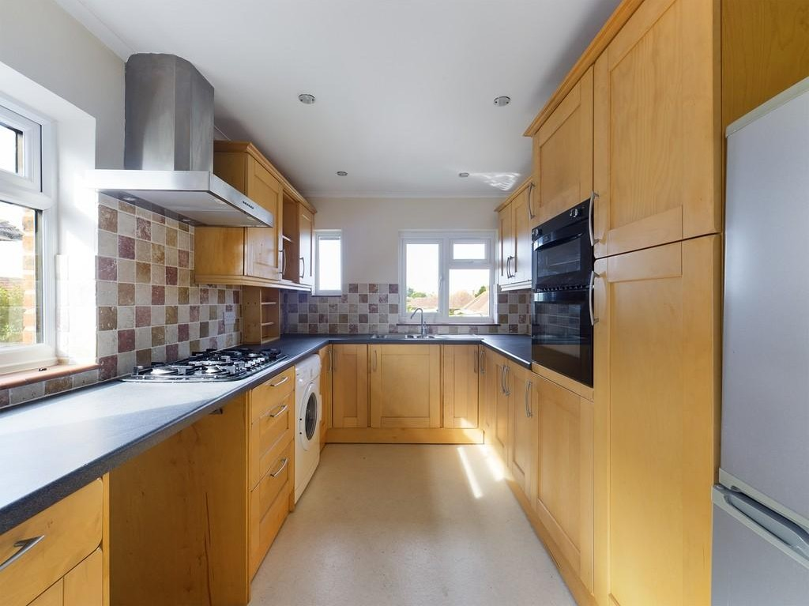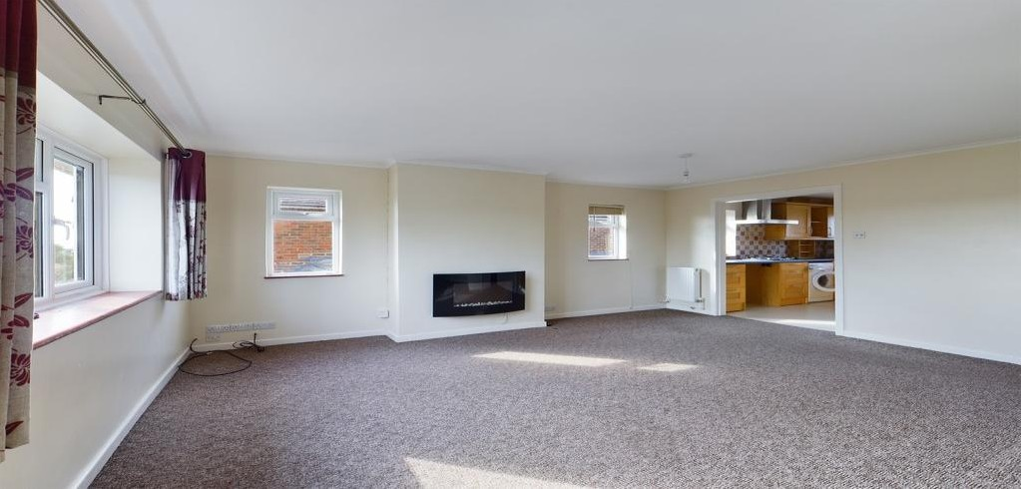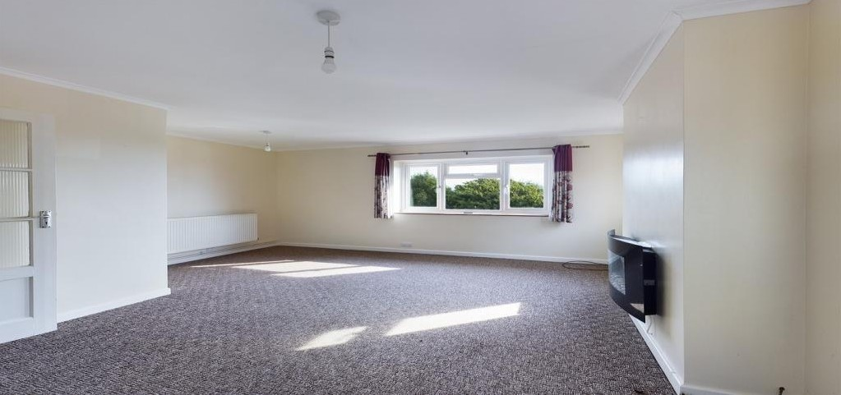

# 

We are pleased to be able to offer a first floor purpose built flat for sale. The property has a private entrance, two double bedrooms and a dual aspect lounge overlooking Goring Gap. The property has the benefit of no ongoing chain.

Property details: 2 St. Malo Court | Ferring | Worthing | BN12 5HE

INTERNAL Private entrance leading into the first entrance hall with stairs rising to the first floor, there is an additional front door leading onto the landing. The lounge/ diner is dual aspect with views overlooking Goring Gap, there is an opening into the fitted kitchen comprising of wall storage cupboards, double oven, five ring gas hob with extractor over, space for washing machine and fridge/ freezer, sink drainer and dual aspect. Th ere are two double bedrooms, bedroom two has built in wardrobes and bedroom one has free standing wardrobes. There are two good size storage cupboard off the entrance hall and a four piece fitted bathroom.



Key features:

* First Floor Purpose Built Flat
* Two Double Bedrooms
* Private Entrance
* Dual Aspect Lounge/ Diner
* Fitted Kitchen
* Four Piece Fitted Bathroom
* Garage In Compound
* Walking Distance to Ferring Seafront
* Freehold
* No Ongoing Chain

2 Bedrooms

1 Bathroom

1 Living Room

EXTERNAL Garage in compound with up and over door and power. Visitors parking to the front of the property.

SITUATED in sought after South Ferring, the property is 350 yards from Ferring seafront. Bus routes run along closeby Sea Lane and Ferring village centre is approximately 1 mile away, offering pharmacy, eateries and convenience shops. Worthing town centre with its comprehensive restaurants, shops and theatres is

approximately 3 miles away.

TENURE Freehold

Service Charge: £999 per annum Ground Rent: Peppercorn

ENTRANCE HALL

LOUNGE *15' 11" x 15' 9" (4.85m x 4.8m)*

KITCHEN *11' 2" x 8' 2" (3.4m x 2.49m)* BEDROOM ONE *12' 11" x 11' 2" (3.94m x 3.4m)* BEDROOM TWO *11' x 12' 3" (3.35m x 3.73m)* BATHROOM

COUNCIL TAX

# 

To book a viewing contact us on: 01903 506080 | info@jacobs- steel.co. uk | jacobs- steel. co. uk

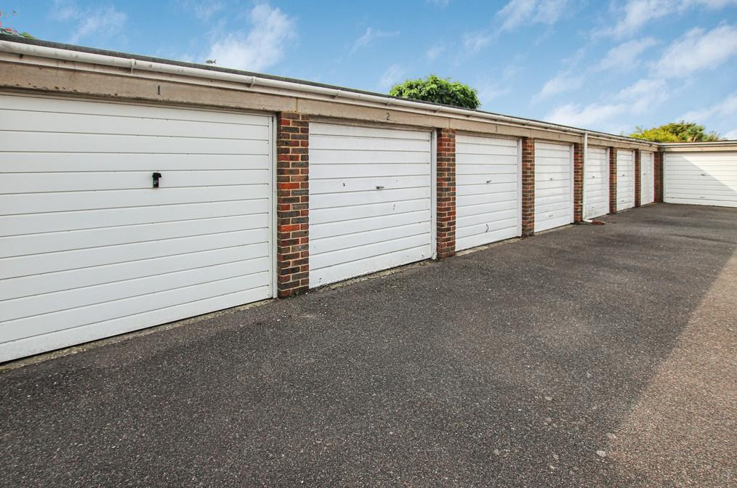

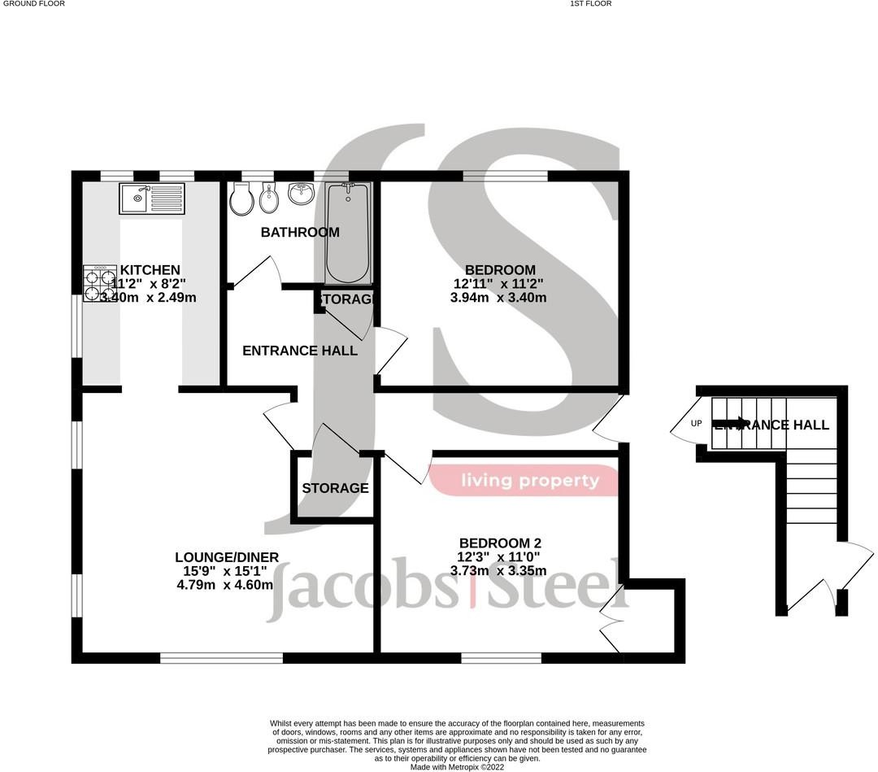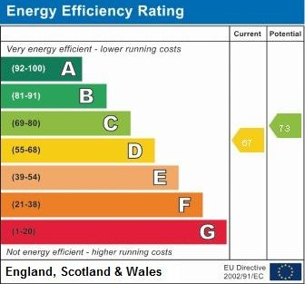

Property Details:

Floor Area: 883 sq ft (82 sq m) – Floor area is quoted from the EPC

Tenure: Freehold Council Tax: Band C

Whilst we endeavour to make our property particulars accurate and reliable, we have not carried out a detailed survey. If the re is any point which is of particular importance to you, please contact the offi ce and we will be pleased to check the information for you, particularly if you are contemplating travelling some di stance. Whilst every effort has been made to ensure that any fl oorplans are correct and drawn as accurately as possible, they are to be used for layout and identifi cation purposes only and are not drawn to scale. The services, where applicable, including electrical equipment and other appliances have not been tested and no warranty can be given that they are in working order, even where described in these particulars. Carpets, curtains, furnishing s, gas fi res, electrical

goods/ fi ttings or other fi xtures, unless expressly mentioned, are not necessarily included with the pr operty.

West Worthing Office | 4 Wallace Parade, Goring Road | Worthing | West Sussex | BN12 4AL 01903 506080 | [info@jacobs-steel.co.uk](mailto:info@jacobs-steel.co.uk) | jacobs-steel.co.uk